- DB First (EF Core) - Scaffold Models
Required Tables: Categories, Products
Terminal command:
dotnet ef dbcontext scaffold "Server=.\sqlexpress;Database=Northwind;Trusted_Connection=True;MultipleActiveResultSets=true;TrustServerCertificate=True" Microsoft.EntityFrameworkCore.SqlServer --output-dir Models --context-dir Data --context AppDBContext --table Categories --table Products
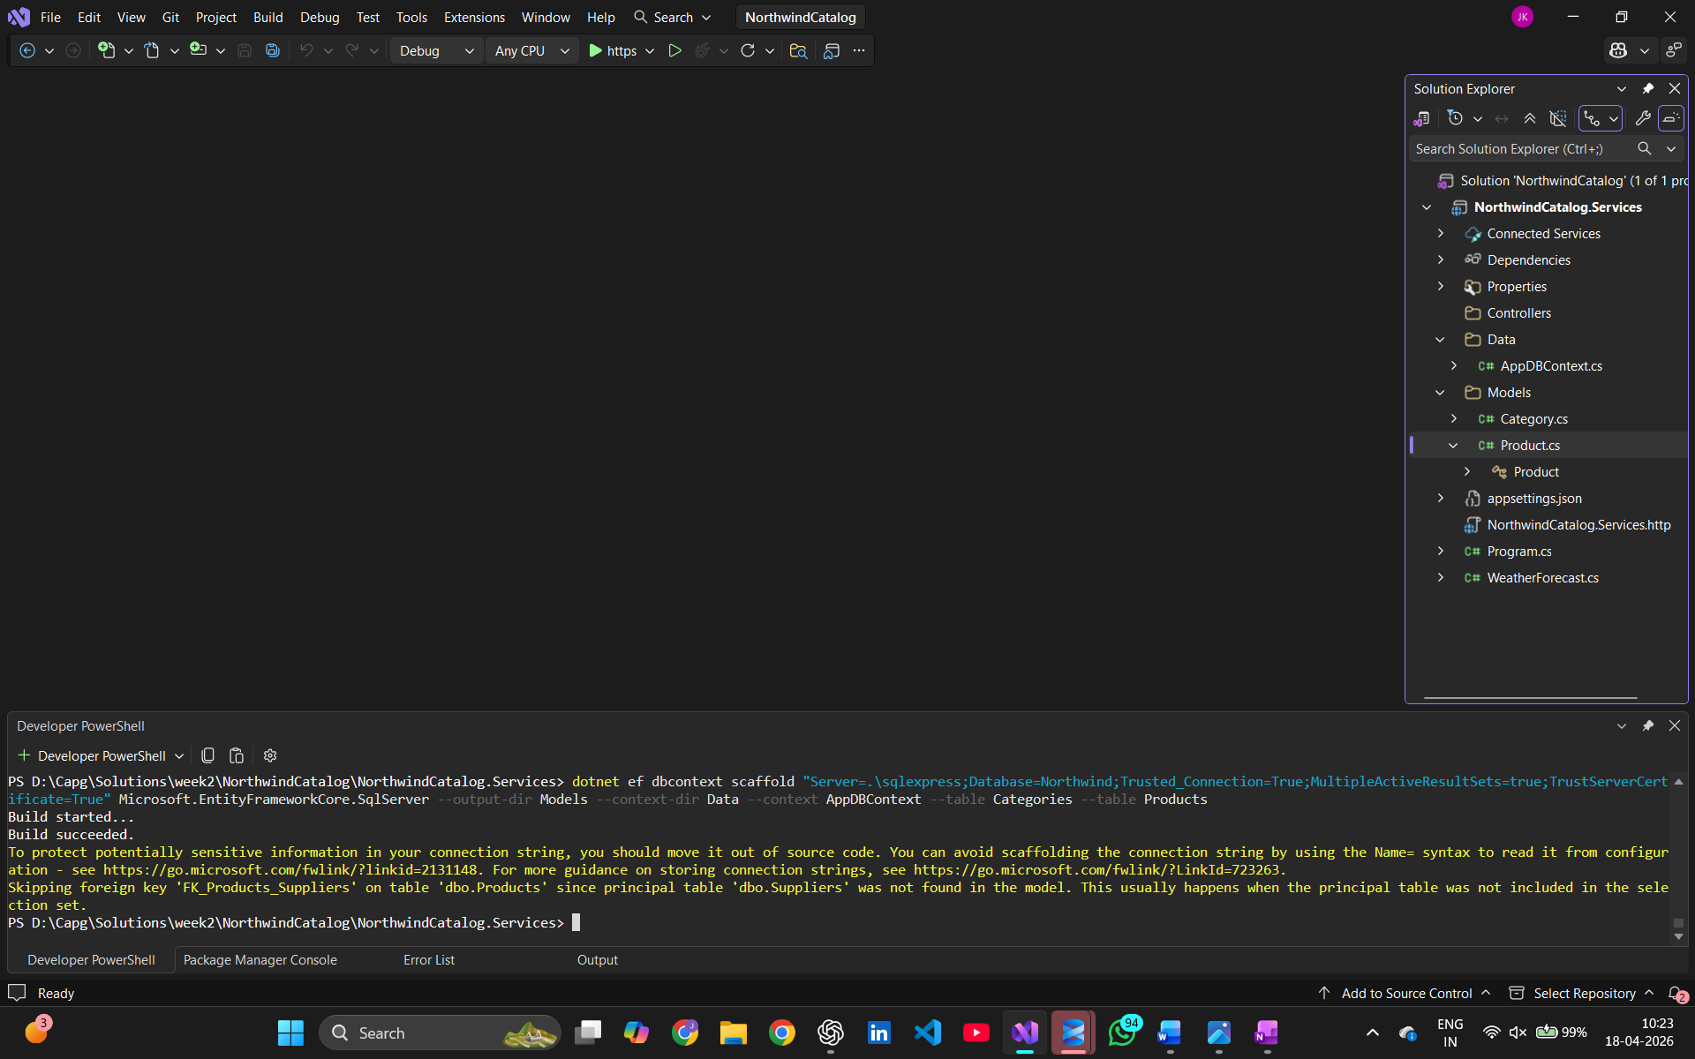

- Fluent API
It is being implemented automatically when we use DB First approach, and the following are created
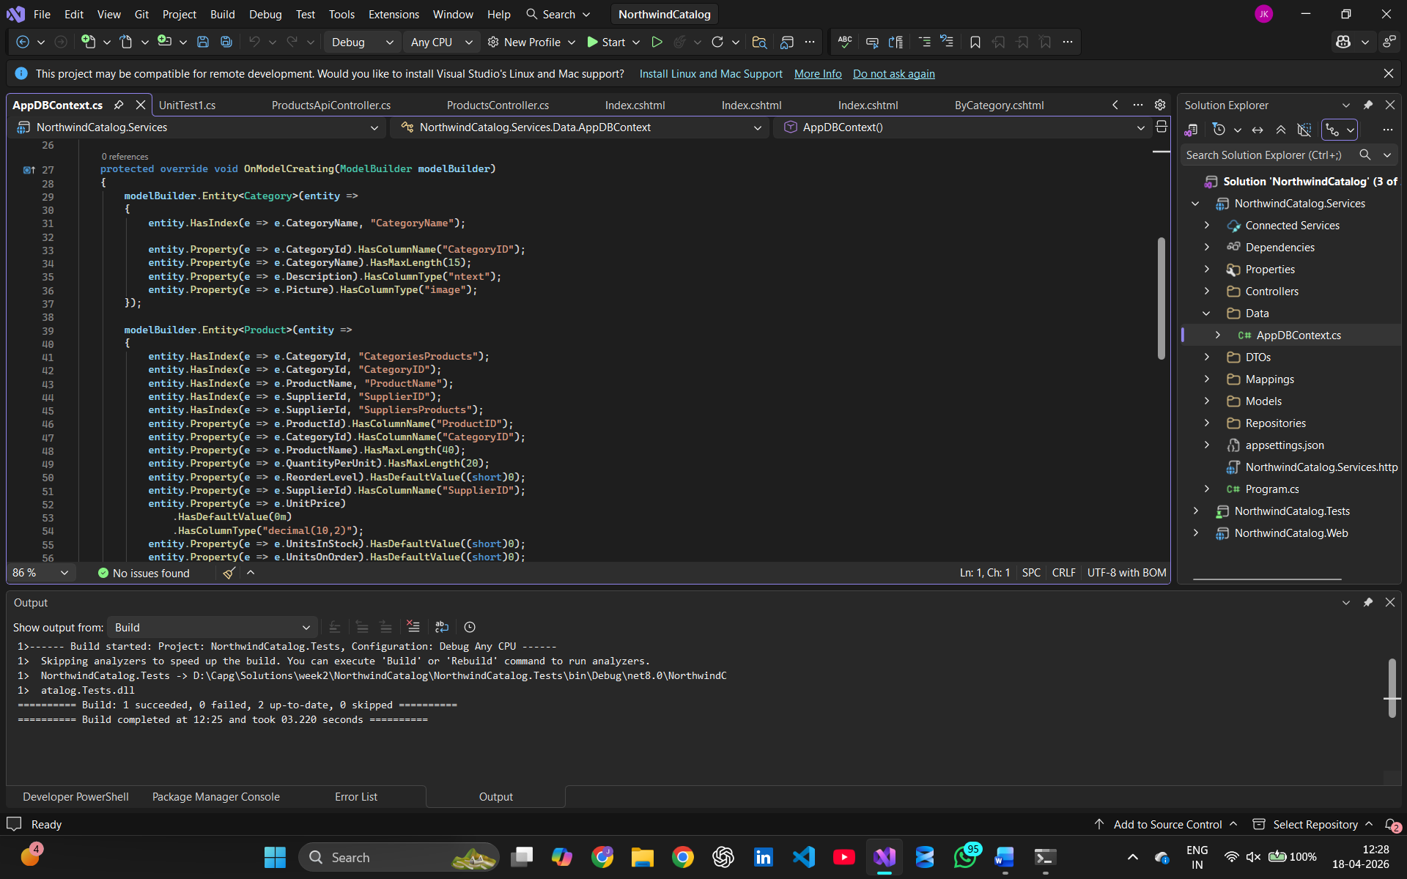

- Creating DTOs
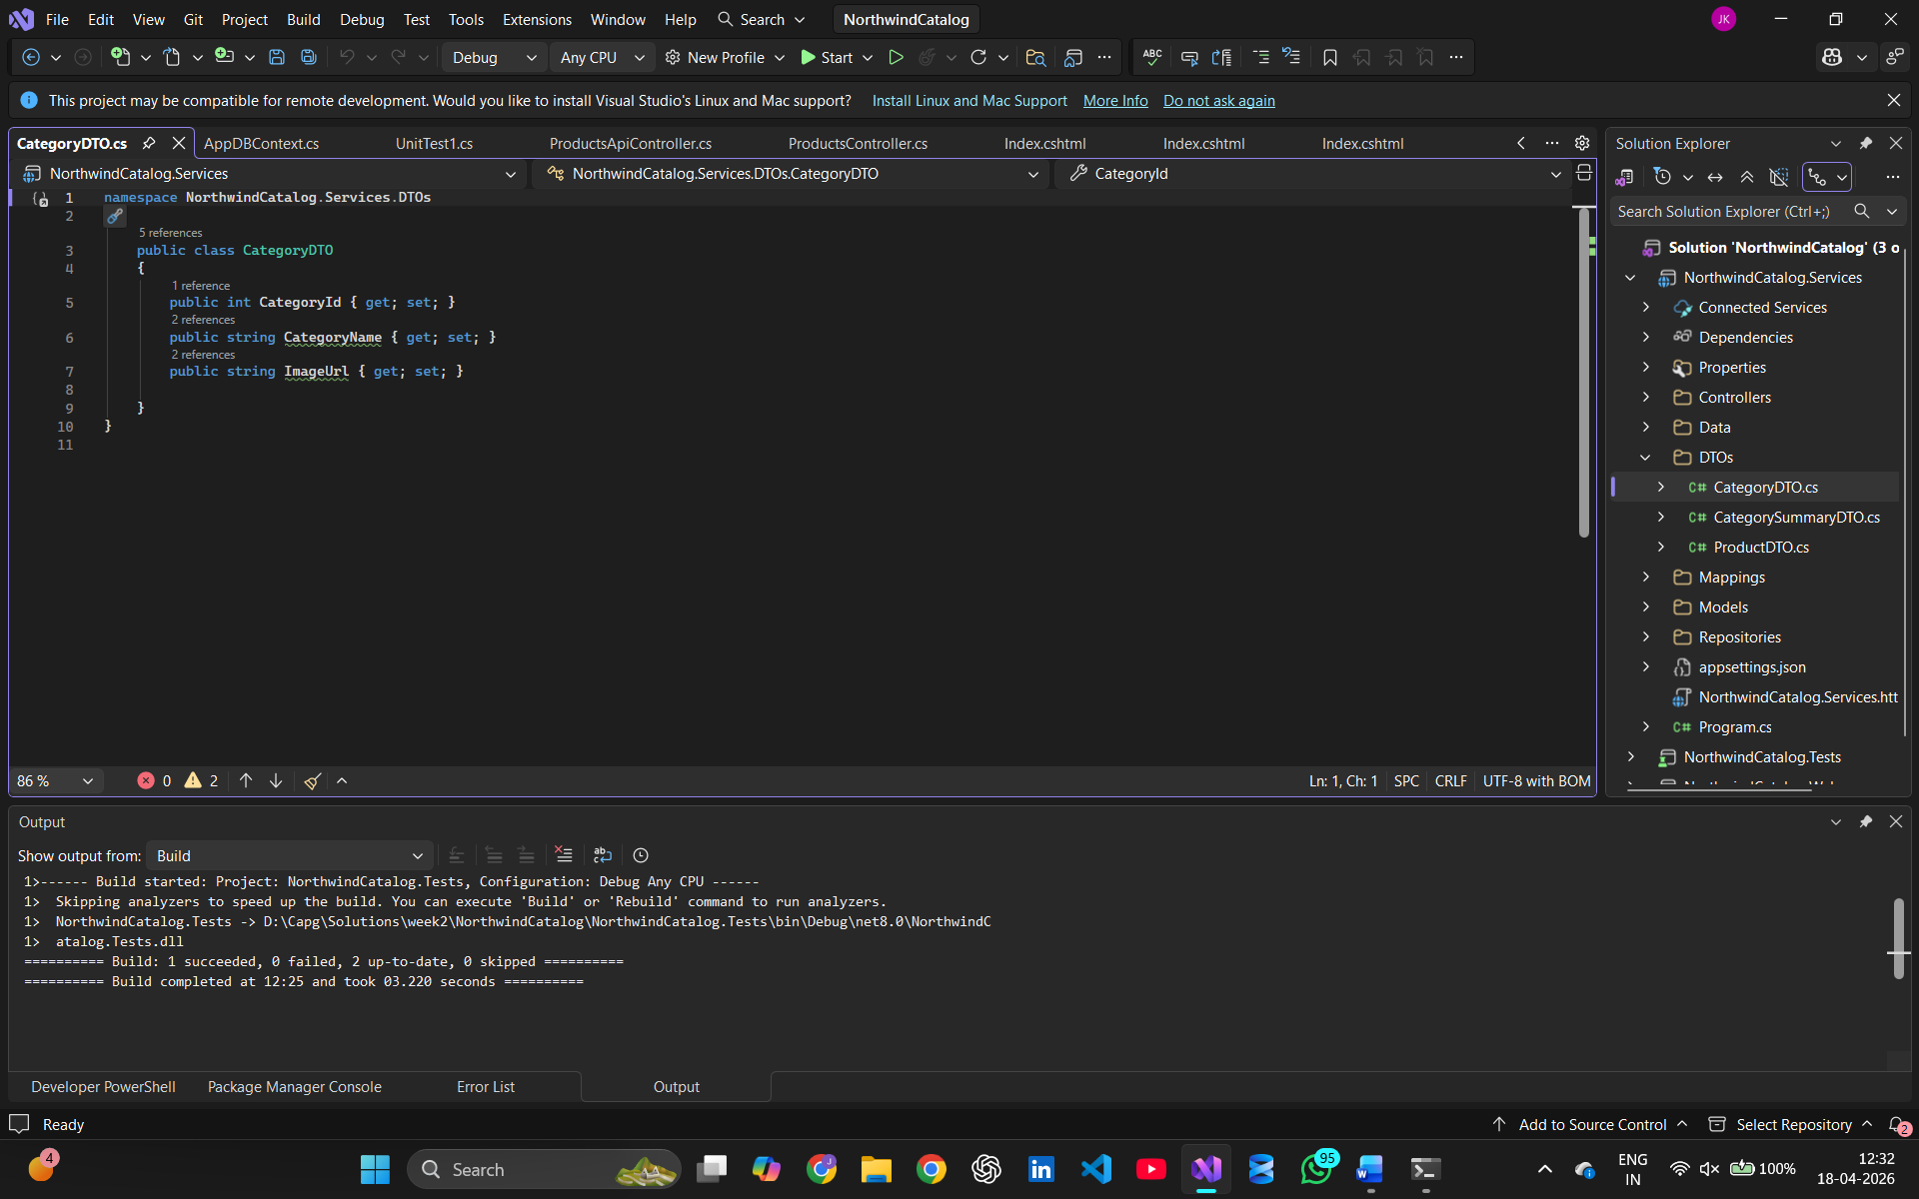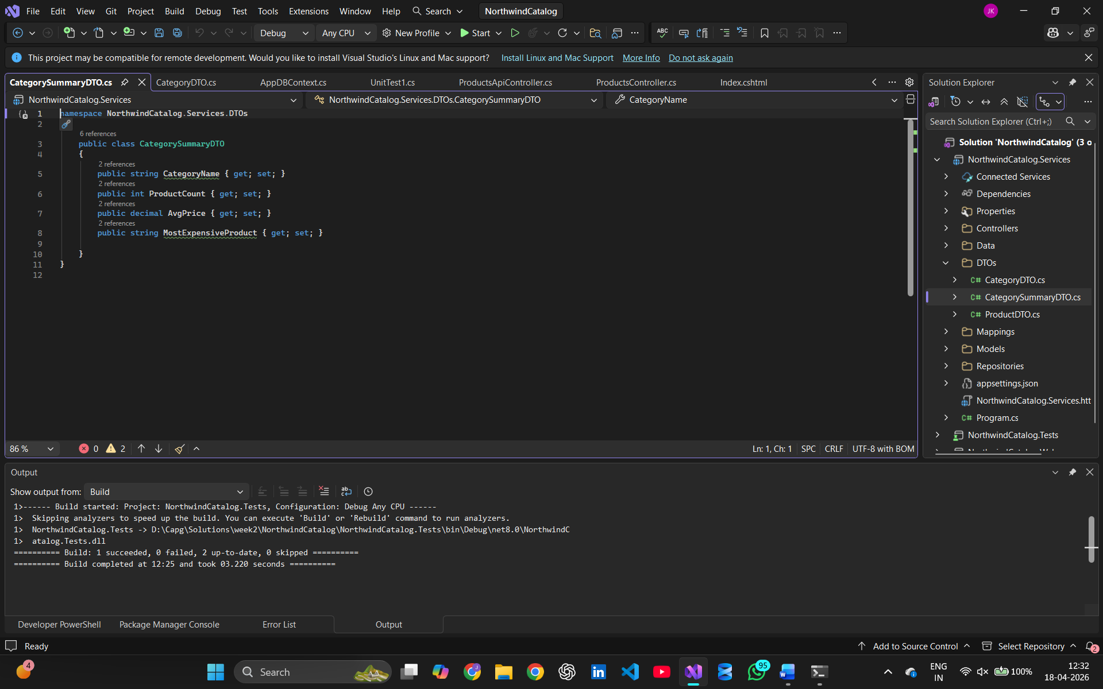
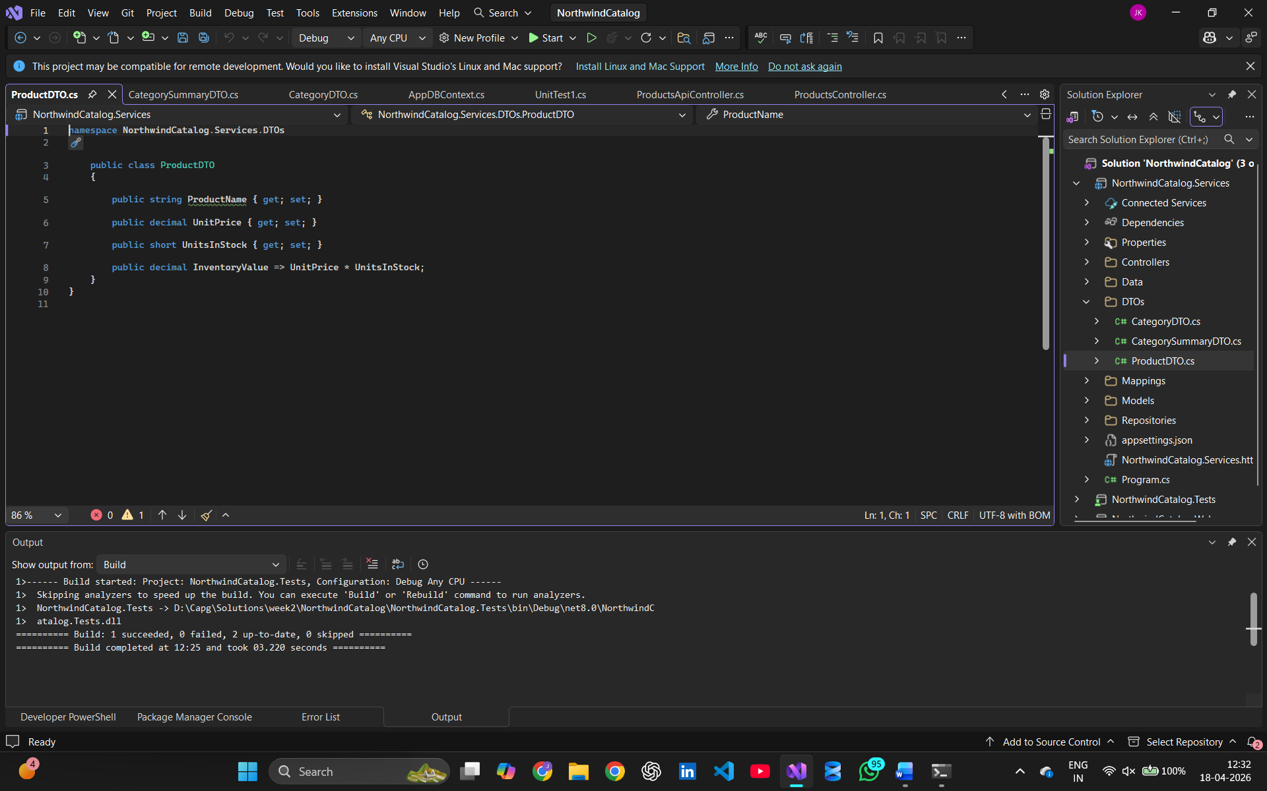

- Using AutoMapper
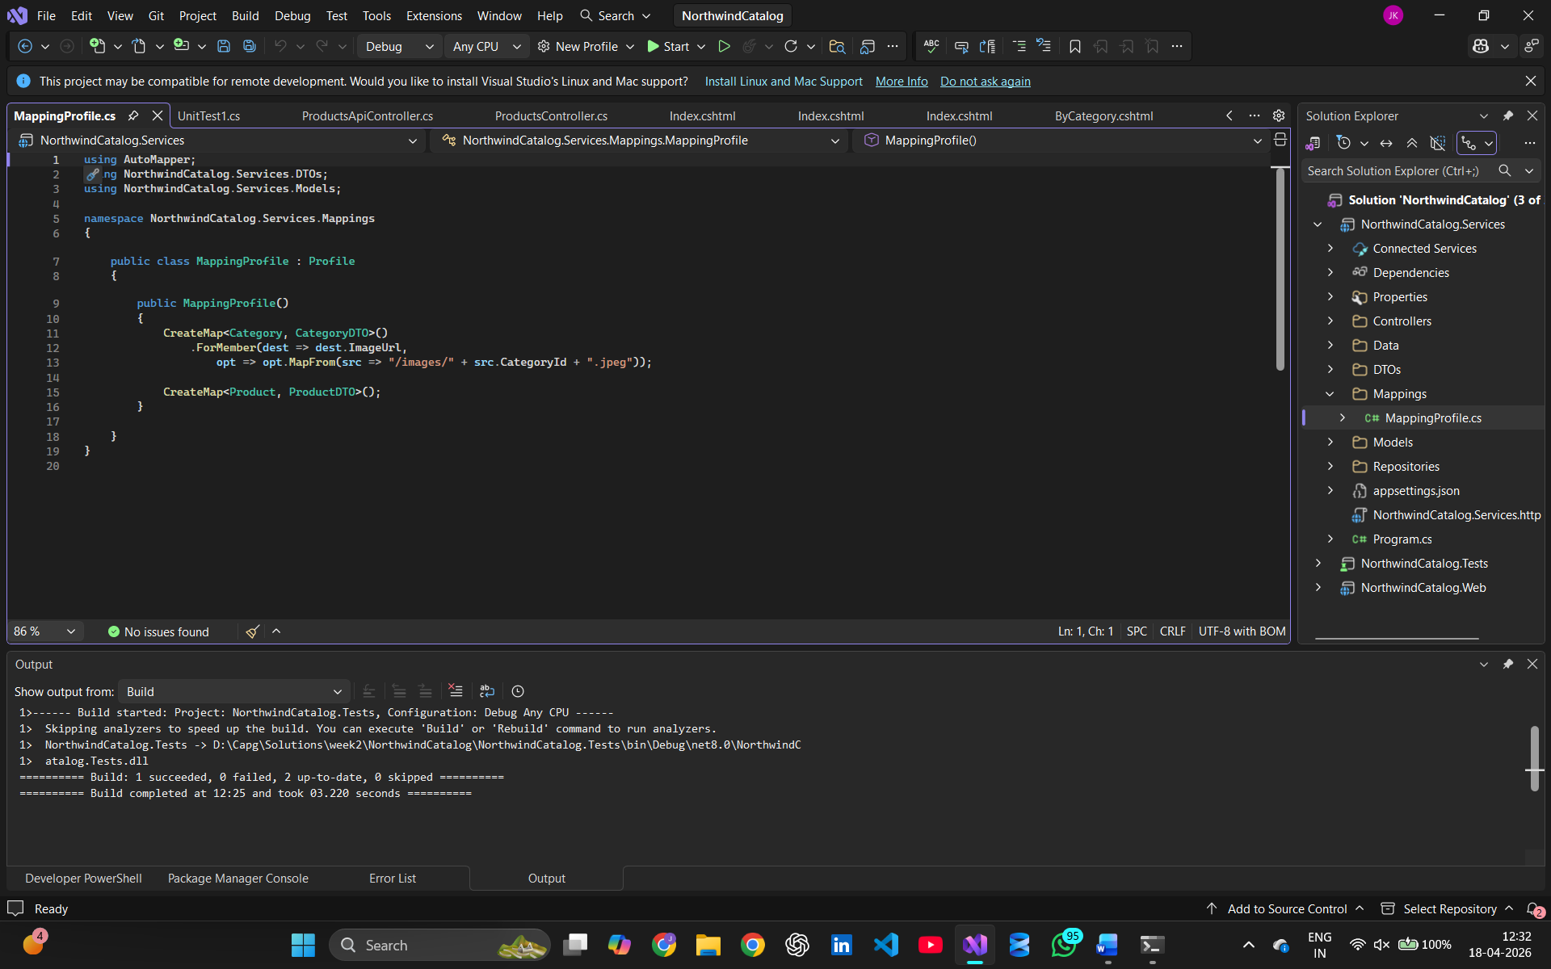

- Using the Repository Pattern
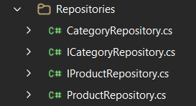

- Controllers (Web API Layer)
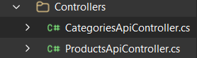
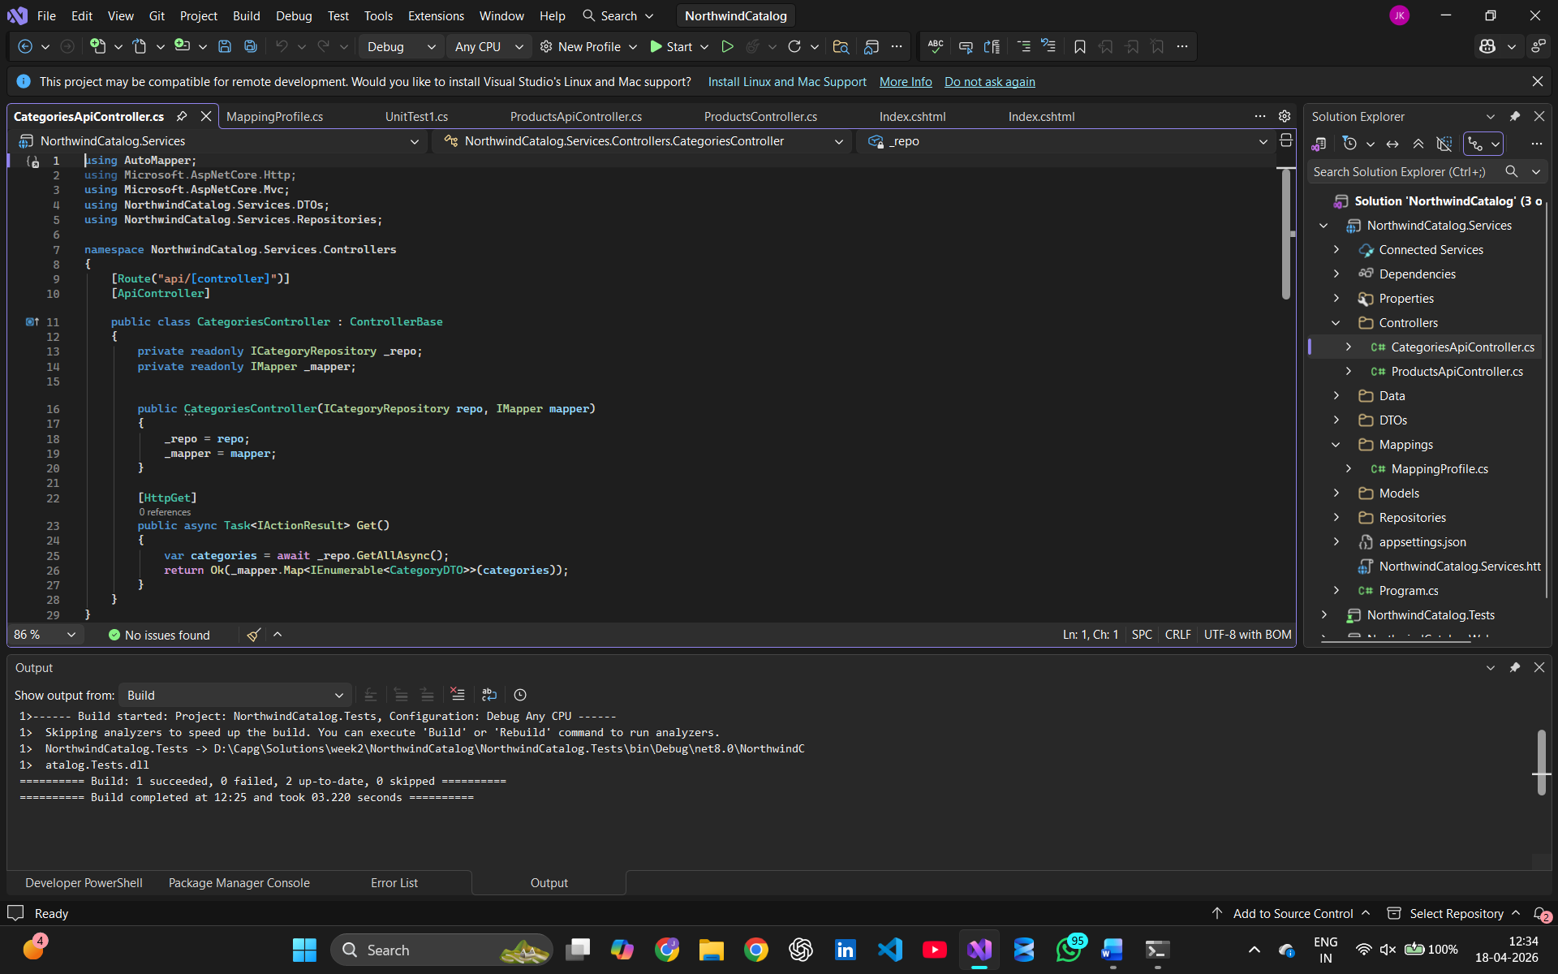
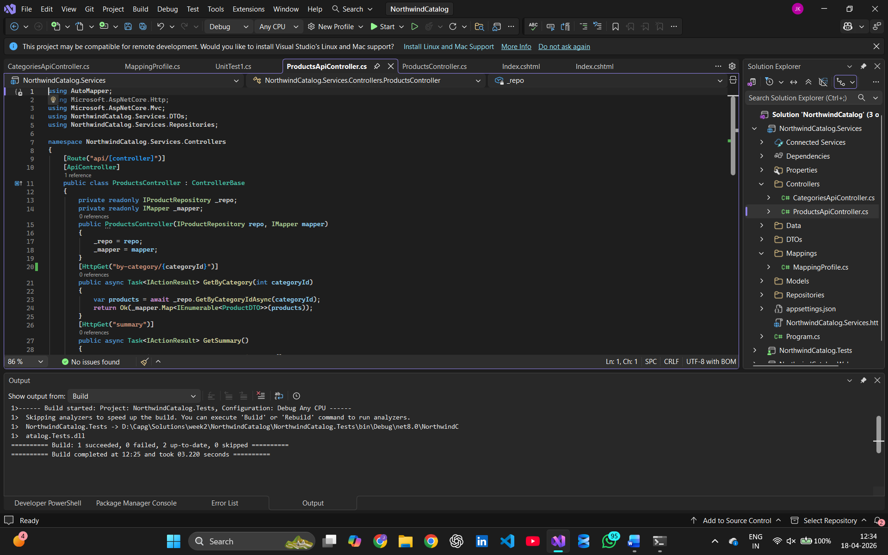

- MVC
Saving the images in wwwroot folder to access them
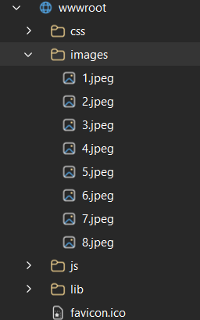

Adding project references so you do not need to create dtos again and can use the dtos of the api project
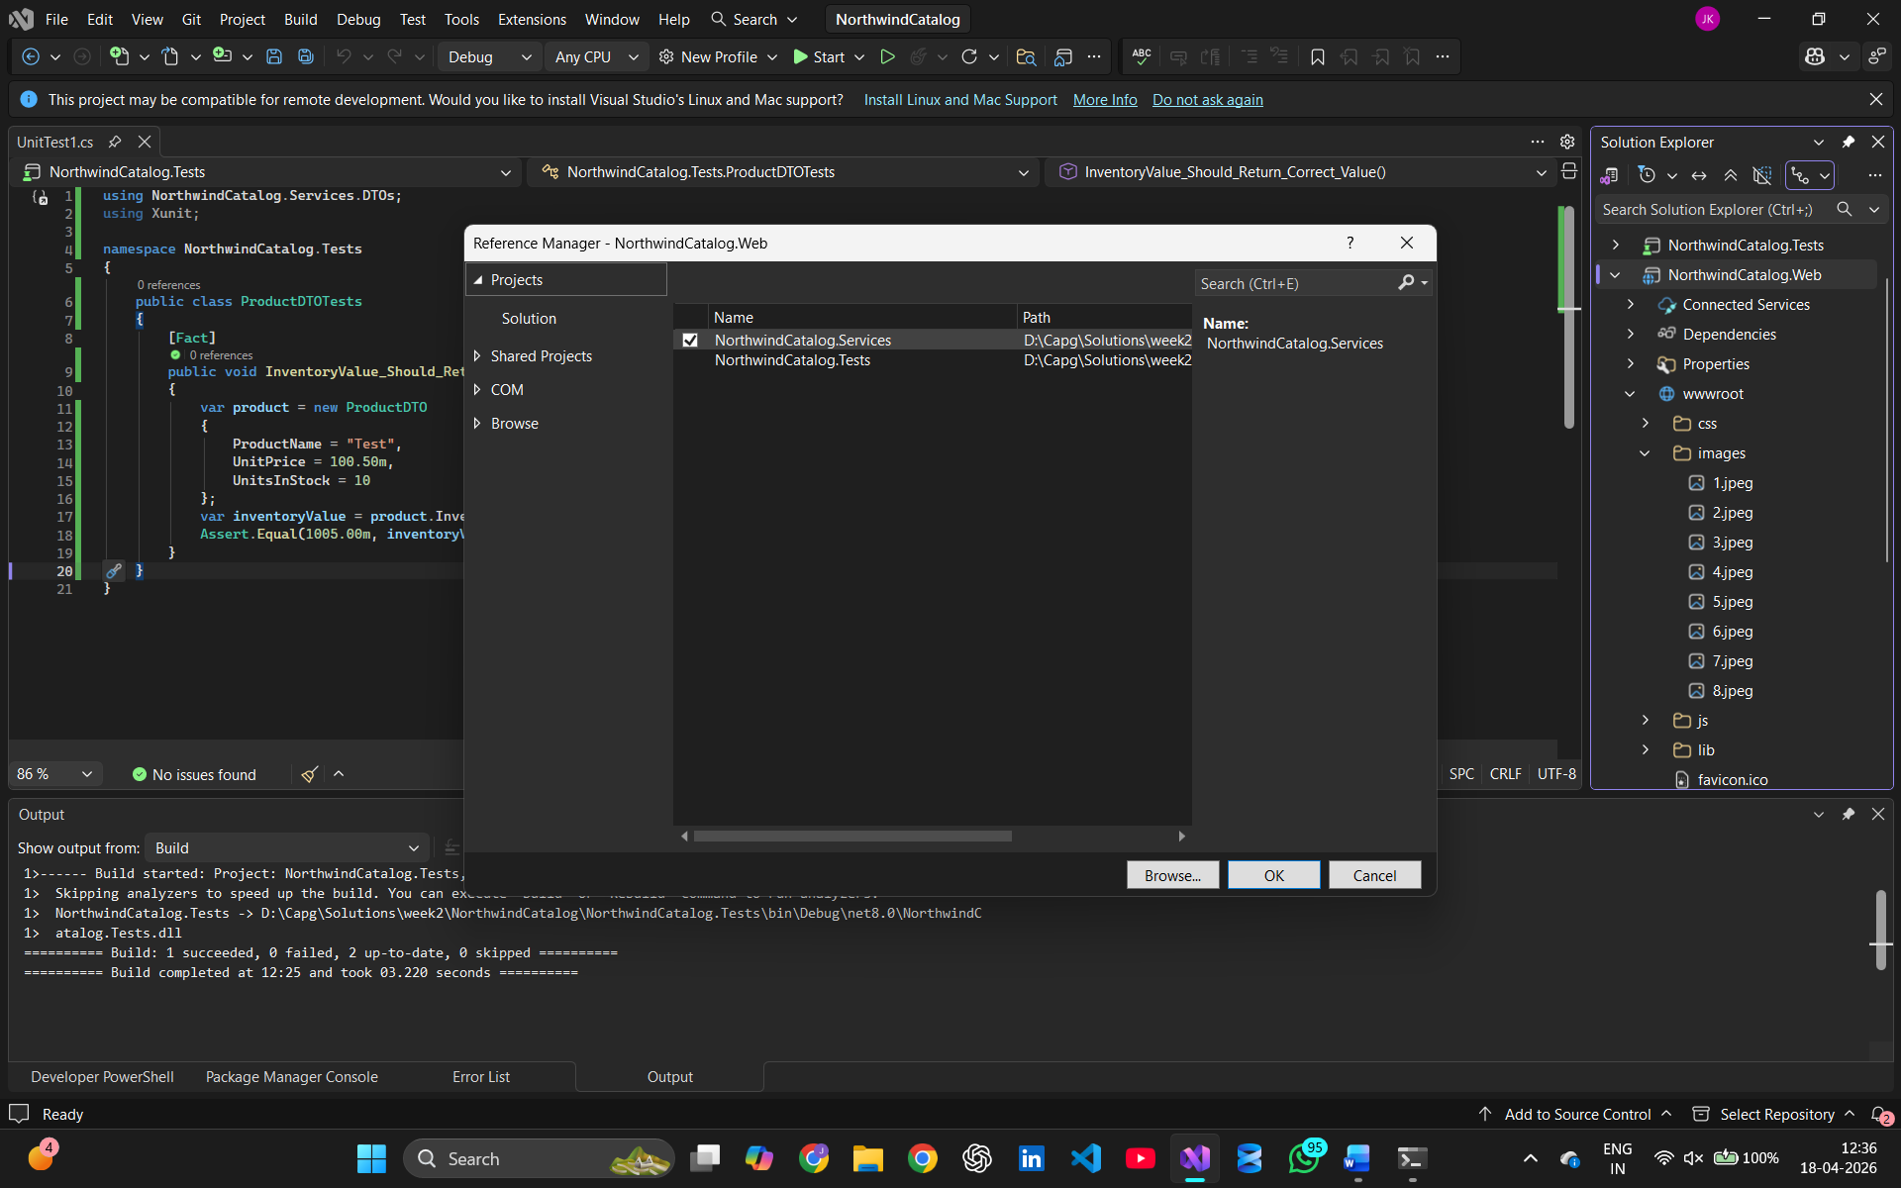

- Fulfilling the UI Requirements
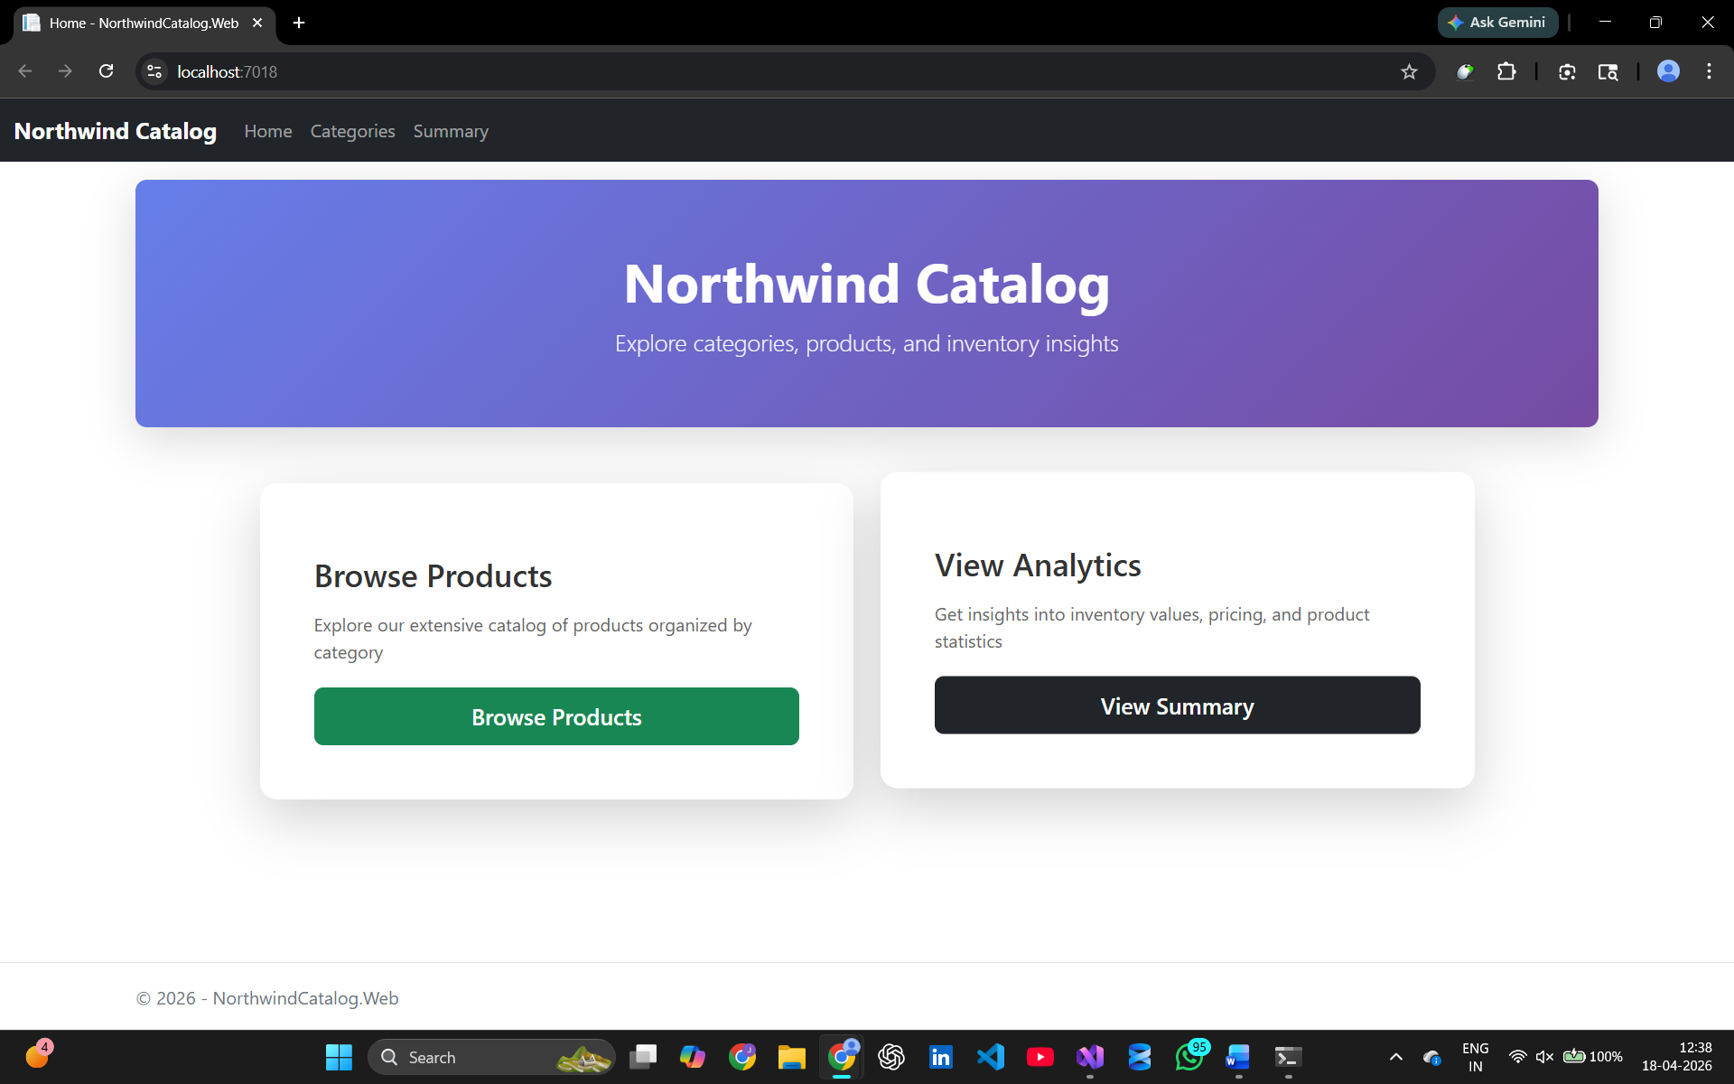
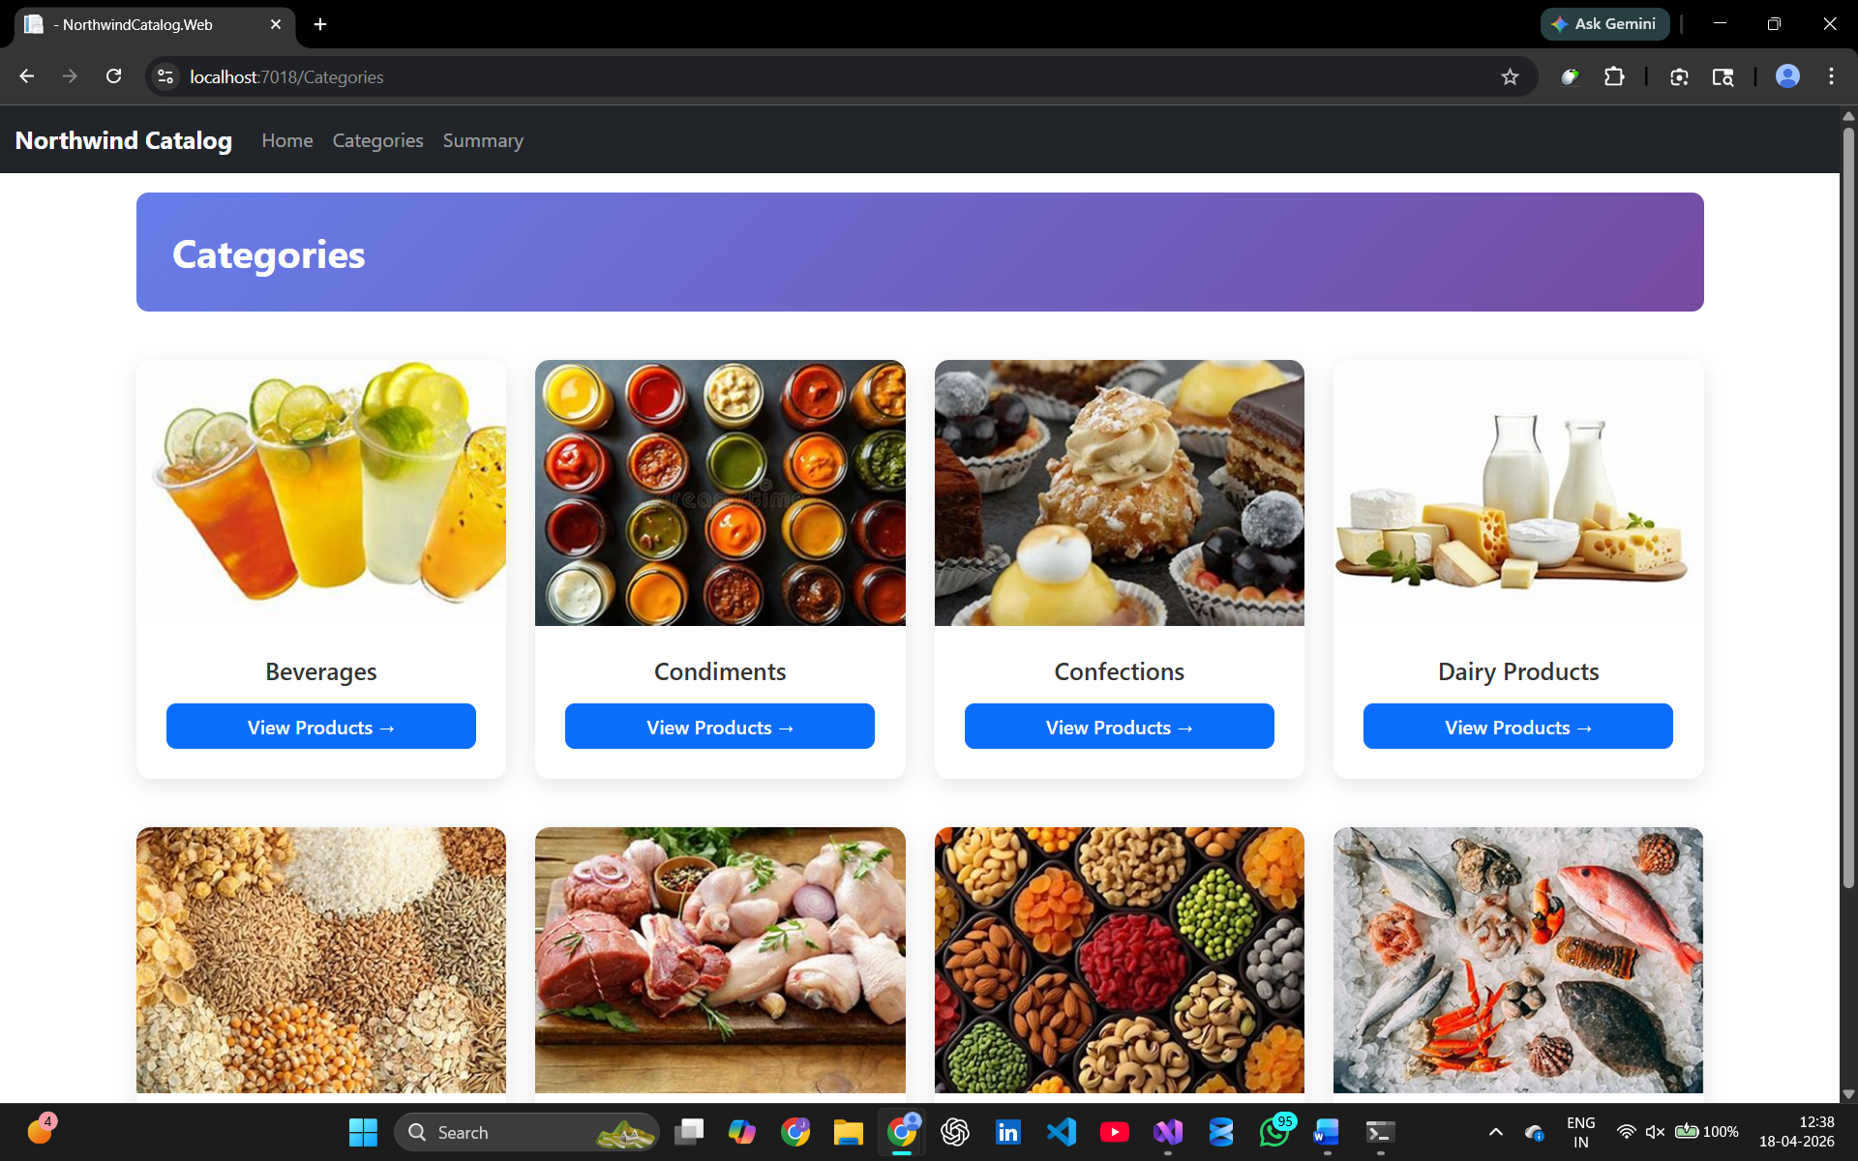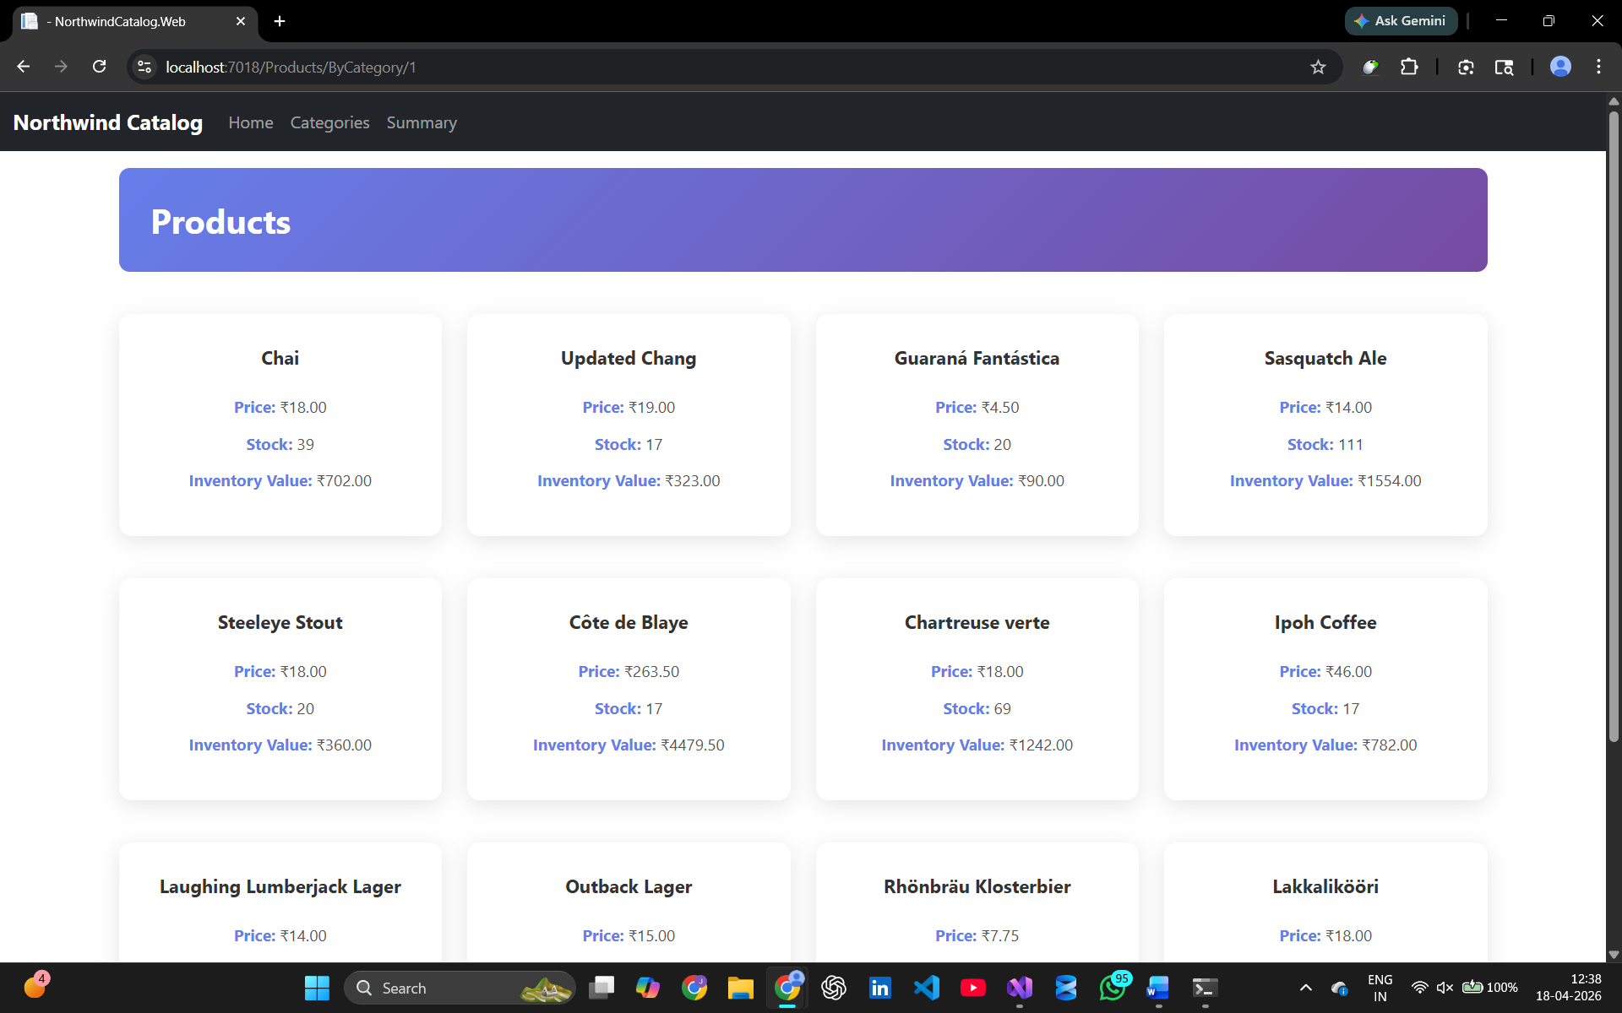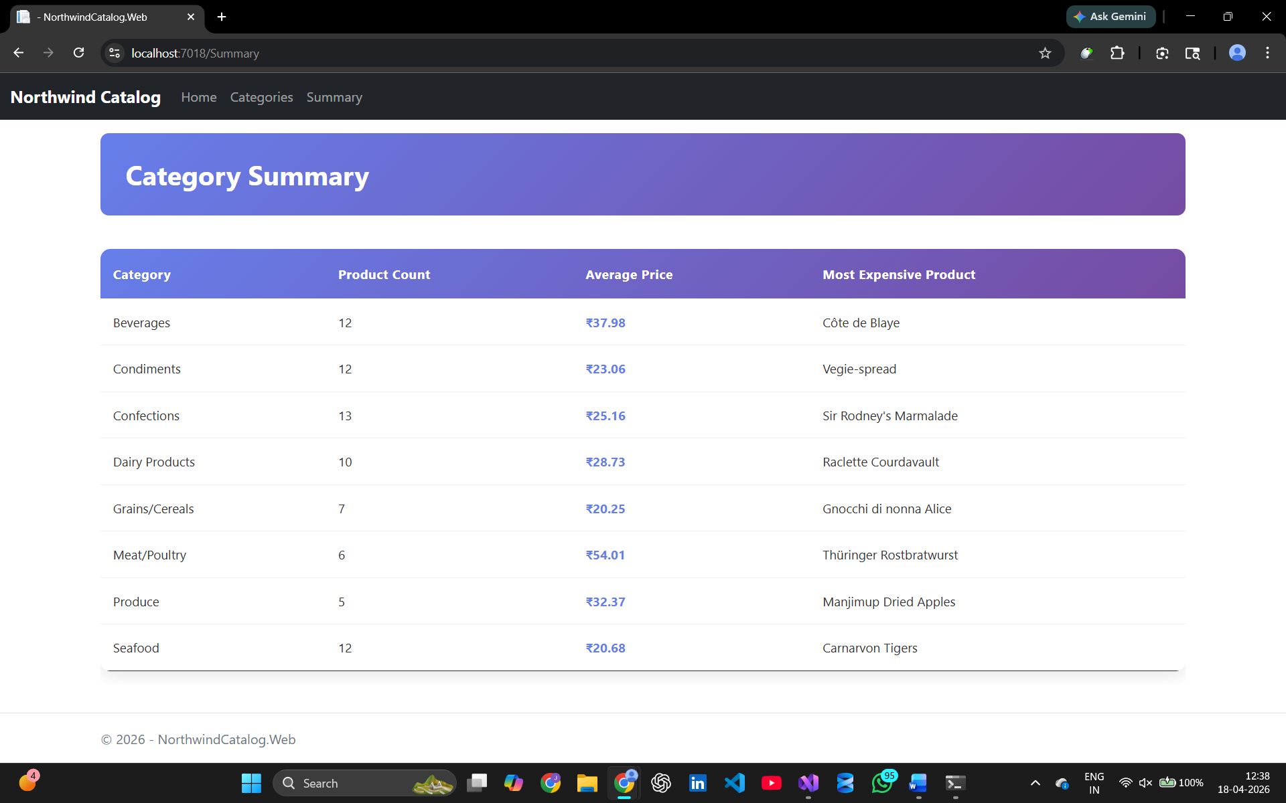

- xUnit Testing
